Suggestions, ideas and resources for supporting pupils with SEMH during any possible home learning time
Being at home for any unplanned prolonged period of time can be tricky for both children and their families. The Advisory Teaching Service have put together a few suggestions of some activities that may be useful during this time.
Mindfulness Strategies. When someone is starting to feel overwhelmed they could have a go at some, or all, of these:
Hi 5 (or finger breathing) can be a really helpful technique for a person to use. Hold your hand out as if you are doing a Hi 5 and trace the index finger on your other hand around the Hi 5 hand. Breathe in as you trace up the fingers and out as you trace down.
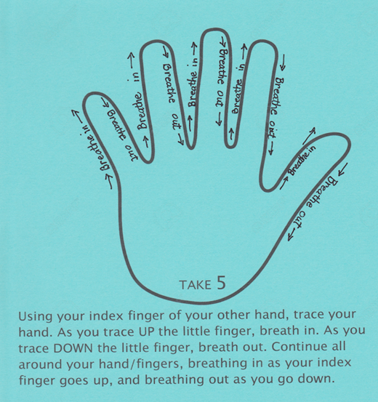
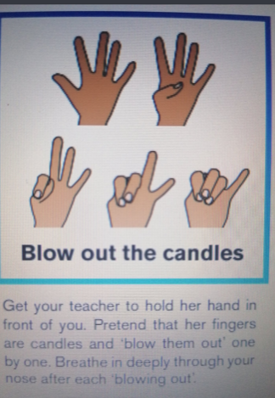
7/11 and candle blow out breathing techniques:

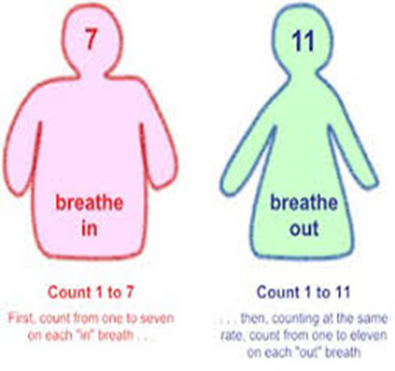

Playdough can be fun to make, great to play with and fabulous to squish. BBC Good Food have the following recipe:
You will need
•8 tbsp plain flour
•2 tbsp table salt
•60ml warm water
•food colouring
•1 tbsp vegetable oil
Method
1. Mix the flour and salt in a large bowl. In a separate bowl mix together the water, a few drops of food colouring and the oil.
2. Pour the coloured water into the flour mix and bring together with a spoon.
3. Dust a work surface with a little flour and turn out the dough. Knead together for a few minutes to form a smooth, pliable dough. If you want a more intense colour you can work in a few extra drops of food colouring.
4. Store in a plastic sandwich bag (squeeze out the air) in the fridge to keep it fresh
You could even make letter sounds (phonics), words or numbers with it
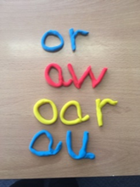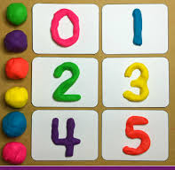

Playing a game with toys you might have at home is great too. How about making sentences with bricks (Lego, Mega blocks etc.)
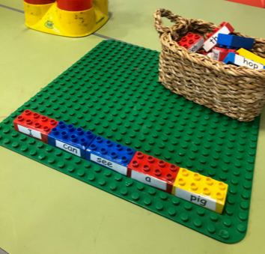 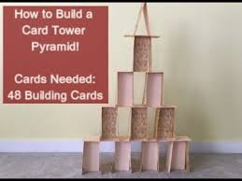 Youtubekids have great clips on card towers!
Touch Base UK have tweeted that they are available for therapeutic consultations and webinars. These are available to parents/carers and professionals. Their email address is info@touchbase.org.uk should you need it.
ChatterPack have put some ideas and links together specifically to support home learning https://chatterpack.net/blogs/blog/resources-list-for-home-learning
The Advisory Teaching Service continues to be open to support, advise and work with settings are pupils. Please do get in contact with us if you would like any further support or advice for pupils on our caselists; we are available on our phone lines or via usual email address.
And finally, the following page has some lovely, fun suggestions of activities to do inside with children if they are not at school. If schools do close, the pupils will get set any appropriate work by their school so please do feel free to give any of these ideas a go too.

